Hypothesis: Factors affecting homelessness in WA, CA, and OR

States Chosen: WA, CA, and OR

Project Description

I am planning my move to the West Coast, and noticed homelessness in the top three states I’d like to migrate to – WA, CA, or OR. This project aims to study the factors affecting homelessness and most ideal state to live in.

Methods

Various datasets were downloaded as .csv files (see Reference for URLs).

For early data analysis, the final compiled dataset was visualized on Tableau.

A correlation plot was also plotted with seaborn’s pairplot() function.

We then conducted a VIF anlaysis to weed out insignificant variables

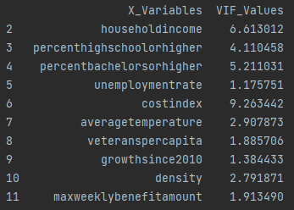 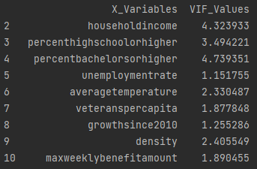

It was decided to remove costindex as it shares an association with householdincome. This makes sense as the cost of goods, housing, and utilities scales with residents’ affluence.

Data Sources

1. <https://www.usich.gov/homelessness-statistics/ca/>
2. <https://www.usich.gov/homelessness-statistics/wa/>
3. <https://www.usich.gov/homelessness-statistics/or/>
4. <https://worldpopulationreview.com/state-rankings/homeless-population-by-state>

Household Income

1. https://worldpopulationreview.com/state-rankings/median-household-income-by-state

Education Attainment

1. https://worldpopulationreview.com/state-rankings/educational-attainment-by-state

Unemployment

1. <https://worldpopulationreview.com/state-rankings/unemployment-benefits-by-state>
2. https://worldpopulationreview.com/state-rankings/unemployment-rate-by-state
3. <https://www.bls.gov/web/laus/laumstrk.htm>

Average temperature by state

1. https://worldpopulationreview.com/state-rankings/average-temperatures-by-state

Cost of living by state

1. https://worldpopulationreview.com/state-rankings/cost-of-living-index-by-state

Analysis

EDA

Correlation plot

totalhomeless ~ "homelesscpt","householdincome", "percenthighschoolorhigher","percentbachelorsorhigher" ,"unemploymentrate", "averagetemperature", "veteranspercapita", "growthsince2010" , "density", "maxweeklybenefitamount"

* Factors affecting homelessness by state
* How it ties back to CA, WA and OR

Summary on Finding